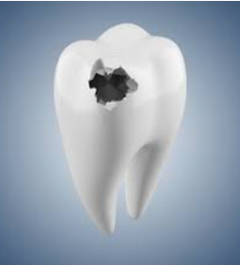 |  | SELF CARE ADVICE FOR YOU AT HOME DURING COVID-19 PANDEMIC
ADVICE OR PRESCRIPTIONS ARE AVAILABLE FROM YOUR DENTIST AT  THIS CURRENT TIME.  Contact  PHONE:  01752 500959  WEBSITE:  Centralparkdentist.co.uk  EMAIL:  cpdental@btconnect.com |  | TEETH THAT HAVE THE FOLLOWING-  HOLE/CRACKED/FILLING OUT- NO PAIN  - Keep the area clean with gentle brushing in the area.  - Temporary filling cements are available at Pharmacies and  supermarkets.  - Always read the instructions before applying.  - Tooth area needs to be dry or the temporary cement may not bond to the tooth.  - Avoid very hot or cold food/drinks, if possible.  HOLE/CRACKED/FILLING OUT- SLIGHT PAIN  - As above instructions.  - Take painkillers if necessary  - Paracetamol and/or Ibuprofen can help settle the pain BUT read the instructions first as TOO MANY WILL NOT IMPROVE THE PAIN but can cause medial problems.  HOLE/CRACKED/FILLING OUT- EXTREME PAIN  - Contact/Email the practice if pain continues or swelling develops.  TAKE CARE AND STAY SAFE.

