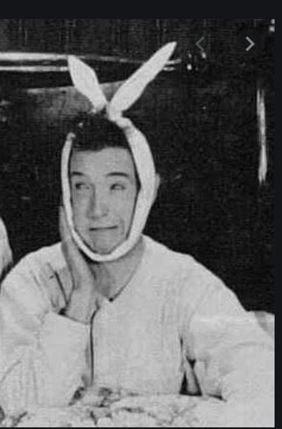 |  | 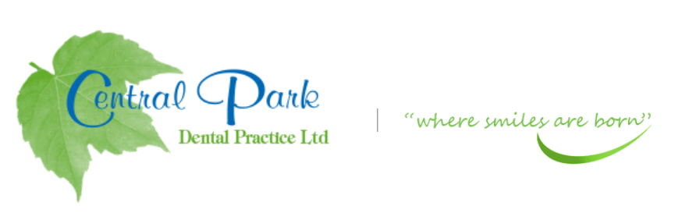  SELF CARE ADVIcE FOR YOU AT HOME DURING COVID-19 PANDEMIC
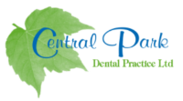  ADVICE OR PRESCRIPTIONS ARE AVAILABLE FROM YOUR DENTIST AT  THIS CURRENT TIME.  CONTACT  TELEPHONE  01752 500959  WEBSITE:  Centralparkdentist.co.uk  EMAIL  cpdental@btconnect.com |  | TEETH THAT HAVE THE FOLLOWING-  TOOTHACHE- MINOR PAIN  - Keep the area clean with gentle brushing in the area with a small headed brush, continue even if it is a little sore.  - Pain is due to inflammation around the gum or in the tooth.  - Good oral hygiene will help until you can see the dentist.  - Avoid sweet/sticky foods that could aggravate the pain.  - Try to limit your frequency of sugary drinks/treats. Consuming to much will not improve the pain but may cause more decay.  - Avoid very hot/cold foods or drinks.  TOOTH ACHE – SLIGHT PAIN  - As above instructions.  - Take painkillers if necessary  - Paracetamol and/or Ibuprofen can help settle the pain BUT read the instructions first as TOO MANY WILL NOT IMPROVE THE PAIN but can cause medial problems.  TOOTH ACHE- EXTREME PAIN  - Contact/Email the practice if pain continues or swelling develops.  TAKE CARE AND STAY SAFE.

