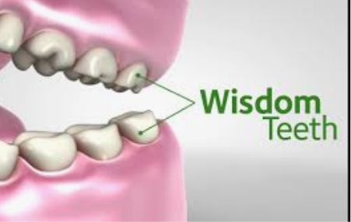 |  | 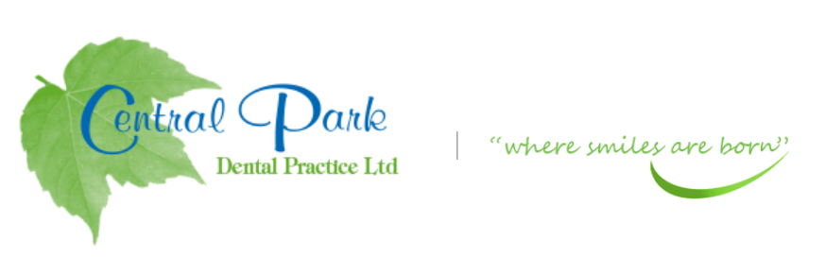  SELF CARE ADVICE FOR YOU AT HOME DURING COVID-19 PANDEMIC
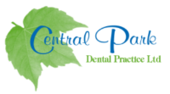  ADVICE OR PRESCRIPTIONS ARE AVAILABLE FROM YOUR DENTIST AT  THIS CURRENT TIME.  Contact  PHONE:  01752 500959  WEBSITE:  Centralparkdentist.co.uk  EMAIL:  cpdental@btconnect.com |  | TEETH THAT HAVE THE FOLLOWING-  WISDON TOOTH- MINOR PAIN  - Keep the area clean with gentle brushing in the area with a small headed brush, continue even if it is a little sore.  - Pain is due to inflammation of the gum around the tooth.  - Most flare ups can be managed with simple measures to improve within a few days.  - Chlorhexidine mouthwash or warm salty water around the area.  - Soft diet to reduce trauma  - Good oral hygiene will help the area to heal quicker.  WISDOM TOOTH – SLIGHT PAIN  - As above instructions.  - Take painkillers if necessary  - Paracetamol and/or Ibuprofen can help settle the pain BUT read the instructions first as TOO MANY WILL NOT IMPROVE THE PAIN but can cause medial problems.  WISDOM TOOTH- EXTREME PAIN  - Contact/Email the practice if pain continues or swelling develops.  TAKE CARE AND STAY SAFE.

